**US Accidents Query Solutions**

***By Somendra, Pablo and Balaji***

## **Query 1**

WITH sev1 as(SELECT DISTINCT count(id) as Acc_Sev1, state

FROM us_accident_v3

WHERE severity = 1

GROUP BY state),

sev2 as(SELECT DISTINCT count(id) as Acc_Sev2, state

FROM us_accident_v3

WHERE severity = 2

GROUP BY state),

sev3 as(SELECT DISTINCT count(id) as Acc_Sev3, state

FROM us_accident_v3

WHERE severity = 3

GROUP BY state),

sev4 as(SELECT DISTINCT count(id) as Acc_Sev4, state

FROM us_accident_v3

WHERE severity = 4

GROUP BY state)

SELECT sev1.state, Acc_Sev1, Acc_Sev2, Acc_Sev3, Acc_Sev4

FROM sev1, sev2, sev3, sev4

WHERE sev1.state = sev2.state AND

sev2.state = sev3.state AND

sev3.state = sev4.state

ORDER BY sev1.state ASC;

## **Query 3**

SELECT DISTINCT

(SELECT avg(date_diff('second',start_time,end_time))

FROM us_accident_v3

WHERE severity = 4) AS Avg_dur_sev_4,

(SELECT stddev(date_diff('second',start_time,end_time))

FROM us_accident_v3

WHERE severity = 4) AS Stddev_dur_sev_4,

(SELECT max(date_diff('second',start_time,end_time))

FROM us_accident_v3

WHERE severity = 4) AS Max_dur_sev_4,

(SELECT avg(date_diff('second',start_time,end_time))

FROM us_accident_v3

WHERE severity = 3) AS Avg_dur_sev_3,

(SELECT stddev(date_diff('second',start_time,end_time))

FROM us_accident_v3

WHERE severity = 3) AS Stddev_dur_sev_3,

(SELECT max(date_diff('second',start_time,end_time))

FROM us_accident_v3

WHERE severity = 3) AS Max_dur_sev_3,

(SELECT avg(date_diff('second',start_time,end_time))

FROM us_accident_v3

WHERE severity = 2) AS Avg_dur_sev_2,

(SELECT stddev(date_diff('second',start_time,end_time))

FROM us_accident_v3

WHERE severity = 2) AS Stddev_dur_sev_2,

(SELECT max(date_diff('second',start_time,end_time))

FROM us_accident_v3

WHERE severity = 2) AS Max_dur_sev_2,

(SELECT avg(date_diff('second',start_time,end_time))

FROM us_accident_v3

WHERE severity = 1) AS Avg_dur_sev_1,

(SELECT stddev(date_diff('hour',start_time,end_time))

FROM us_accident_v3

WHERE severity = 1) AS Stddev_dur_sev_1,

(SELECT max(date_diff('second',start_time,end_time))

FROM us_accident_v3

WHERE severity = 1) AS Max_dur_sev_1

FROM us_accident_v3

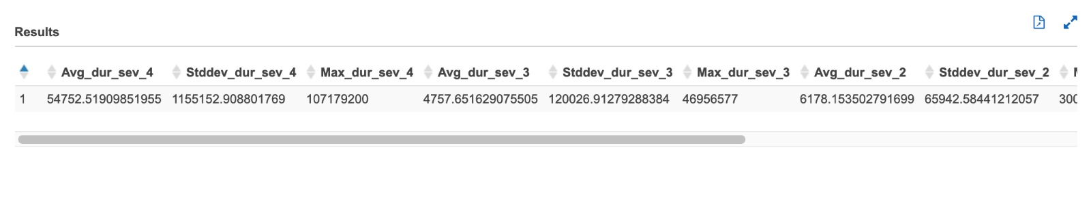

## **Query 4**

with cte1 as

(select date_format(start_time, '%Y-%m-%d') AS date,

weather_condition,

case

when weather_condition = 'Clear' then 'GOOD'

when weather_condition = 'Cloudy' then 'GOOD'

when weather_condition = 'Cloudy / Windy' then 'GOOD'

when weather_condition = 'Drizzle' then 'GOOD'

when weather_condition = 'Drizzle / Windy' then 'GOOD'

when weather_condition = 'Fair' then 'GOOD'

when weather_condition = 'Fair / Windy' then 'GOOD'

when weather_condition = 'Haze' then 'GOOD'

when weather_condition = 'Light Blowing Snow' then 'GOOD'

when weather_condition = 'Light Drizzle' then 'GOOD'

when weather_condition = 'Light Drizzle / Windy' then 'GOOD'

when weather_condition = 'Light Fog' then 'GOOD'

when weather_condition = 'Light Freezing Drizzle' then 'GOOD'

when weather_condition = 'Light Freezing Fog' then 'GOOD'

when weather_condition = 'Light Freezing Rain' then 'GOOD'

when weather_condition = 'Light Freezing Rain / Windy' then 'GOOD'

when weather_condition = 'Light Hail' then 'GOOD'

when weather_condition = 'Light Haze' then 'GOOD'

when weather_condition = 'Light Ice Pellets' then 'GOOD'

when weather_condition = 'Light Rain' then 'GOOD'

when weather_condition = 'Light Rain / Windy' then 'GOOD'

when weather_condition = 'Light Rain Shower' then 'GOOD'

when weather_condition = 'Light Rain Shower / Windy' then 'GOOD'

when weather_condition = 'Light Rain Showers' then 'GOOD'

when weather_condition = 'Light Sleet' then 'GOOD'

when weather_condition = 'Light Snow' then 'GOOD'

when weather_condition = 'Light Snow and Sleet' then 'GOOD'

when weather_condition = 'Light Snow Grains' then 'GOOD'

when weather_condition = 'Light Snow Shower' then 'GOOD'

when weather_condition = 'Light Snow Showers' then 'GOOD'

when weather_condition = 'Light Thunderstthen' then 'GOOD'

when weather_condition = 'Light Thunderstthen' then 'GOOD'

when weather_condition = 'Mist' then 'GOOD'

when weather_condition = 'Mostly Cloudy' then 'GOOD'

when weather_condition = 'Mostly Cloudy / Windy' then 'GOOD'

when weather_condition = 'N/A Precipitation' then 'GOOD'

when weather_condition = 'Overcast' then 'GOOD'

when weather_condition = 'Partial Fog' then 'GOOD'

when weather_condition = 'Partial Fog / Windy' then 'GOOD'

when weather_condition = 'Partly Cloudy' then 'GOOD'

when weather_condition = 'Partly Cloudy / Windy' then 'GOOD'

when weather_condition = 'Patches of Fog' then 'GOOD'

when weather_condition = 'Scattered Clouds' then 'GOOD'

when weather_condition = 'Shallow Fog' then 'GOOD'

when weather_condition = 'Showers in the Vicinity' then 'GOOD'

when weather_condition = 'Small Hail' then 'GOOD'

when weather_condition = 'Thunder in the Vicinity' then 'GOOD'

else 'BAD' end as weather_type

, severity

from us_accident_v3),

cte2 as

(select *,

case

when severity = 1 and weather_type = 'GOOD' then 'sev1_GOOD'

when severity = 2 and weather_type = 'GOOD' then 'sev2_GOOD'

when severity = 3 and weather_type = 'GOOD' then 'sev3_GOOD'

when severity = 4 and weather_type = 'GOOD' then 'sev4_GOOD'

when severity = 1 and weather_type = 'BAD' then 'sev1_BAD'

when severity = 2 and weather_type = 'BAD' then 'sev2_BAD'

when severity = 3 and weather_type = 'BAD' then 'sev3_BAD'

when severity = 4 and weather_type = 'BAD' then 'sev4_BAD'

else 'unknown_weather' end as GOOD_BAD_sev

from cte1),

cte3 as

(select date,GOOD_BAD_sev,count(*) as number_of_accident from cte2 group by date,GOOD_BAD_sev

order by date,GOOD_BAD_sev asc),

cte4 as

(select date,GOOD_BAD_sev, a.number_of_accident, cast(a.number_of_accident as double)*100/b.tot_accident as percent_accident from cte3 a

cross join

(select count(*) as tot_accident from cte2) b)

select date, q1['sev1_GOOD'] as Sev_1_perc_GOOD_weather,

q2['sev2_GOOD'] as Sev_2_perc_GOOD_weather,

q3['sev3_GOOD'] as Sev_3_perc_GOOD_weather,

q4['sev4_GOOD'] as Sev_4_perc_GOOD_weather,

q5['sev1_BAD'] as Sev_1_perc_BAD_weather,

q6['sev2_BAD'] as Sev_2_perc_BAD_weather,

q7['sev3_BAD'] as Sev_3_perc_BAD_weather,

q8['sev4_BAD'] as Sev_4_perc_BAD_weather

from (

select date, map_agg(GOOD_BAD_sev, percent_accident) q1,

map_agg(GOOD_BAD_sev, percent_accident) q2,

map_agg(GOOD_BAD_sev, percent_accident) q3,

map_agg(GOOD_BAD_sev, percent_accident) q4,

map_agg(GOOD_BAD_sev, percent_accident) q5,

map_agg(GOOD_BAD_sev, percent_accident) q6,

map_agg(GOOD_BAD_sev, percent_accident) q7,

map_agg(GOOD_BAD_sev, percent_accident) q8

from cte4

group by date)

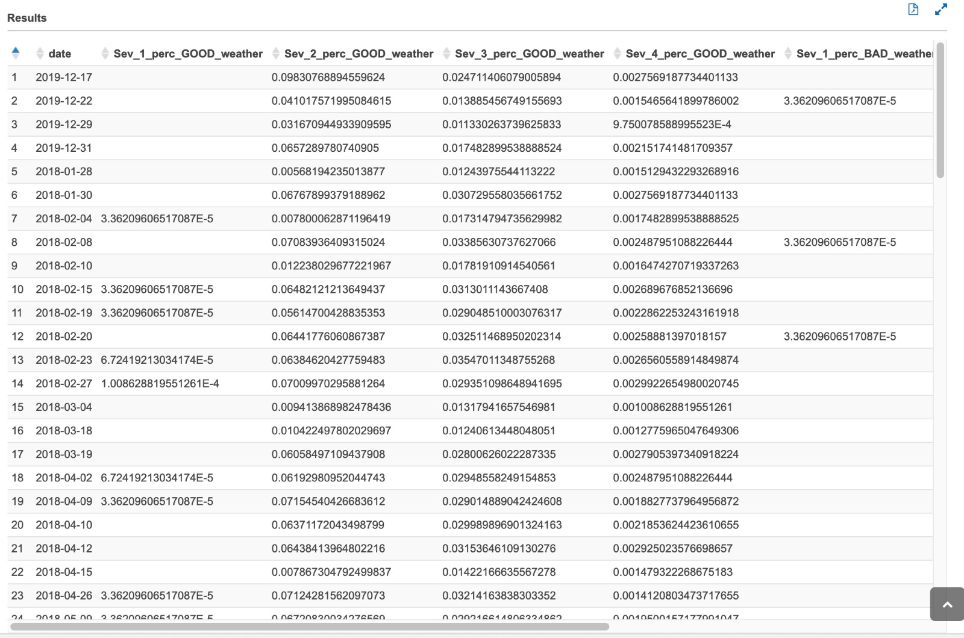

## **Query 5**

**temperature**

select date, temp_range_in_f, severity, weather_condn, count(*) as cnt

from

(select date(start_time) as date,

case

when temperature between -80 and -71 then '-80 to -71'

when temperature between -70 and -61 then '-70 to -61'

when temperature between -60 and -51 then '-60 to -51'

when temperature between -50 and -41 then '-50 to -41'

when temperature between -40 and -31 then '-40 to -31'

when temperature between -30 and -21 then '-30 to -21'

when temperature between -20 and -11 then '-20 to -11'

when temperature between -10 and -1 then '-10 to -01'

when temperature between 0 and 9 then '0 to 9'

when temperature between 10 and 19 then '10 to 19'

when temperature between 20 and 29 then '20 to 29'

when temperature between 30 and 39 then '30 to 39'

when temperature between 40 and 49 then '40 to 49'

when temperature between 50 and 59 then '50 to 59'

when temperature between 60 and 69 then '60 to 69'

when temperature between 70 and 79 then '70 to 79'

when temperature between 80 and 89 then '80 to 89'

when temperature between 90 and 99 then '90 to 99'

when temperature between 100 and 109 then '100 to 109'

when temperature between 110 and 119 then '110 to 119'

when temperature between 120 and 129 then '120 to 129'

when temperature between 130 and 139 then '130 to 139'

when temperature between 140 and 149 then '140 to 149'

when temperature between 150 and 159 then '150 to 159'

when temperature between 160 and 169 then '160 to 169'

when temperature between 170 and 179 then '170 to 179'

else 'temperature unknown'

end as temp_range_in_f,

case

when weather_condition = 'Clear' then 'good'

when weather_condition like 'Cloudy%' then 'good'

when weather_condition = 'Drizzle' then 'good'

when weather_condition = 'Drizzle / Windy' then 'good'

when weather_condition like 'Fair%' then 'good'

when weather_condition = 'Haze' then 'good'

when weather_condition like 'Light%' then 'good'

when weather_condition = 'Mist' then 'good'

when weather_condition like 'Mostly%' then 'good'

when weather_condition = 'N/A Precipitation' then 'good'

when weather_condition = 'Overcast' then 'good'

when weather_condition like 'Partial%' then 'good'

when weather_condition like 'Partly%' then 'good'

when weather_condition = 'Patches of Fog' then 'good'

when weather_condition = 'Scattered Clouds' then 'good'

when weather_condition = 'Shallow Fog' then 'good'

when weather_condition = 'Showers in the Vicinity' then 'good'

when weather_condition = 'Small Hail' then 'good'

when weather_condition = 'Thunder in the Vicinity' then 'good'

else 'bad'

end as weather_condn, severity

from us_accident_v3

where year(start_time) = 2019 and month(start_time) = 12 and day(start_time) = 31

order by month(start_time), date(start_time))

group by weather_condn, severity, temp_range_in_f, date

order by temp_range_in_f, severity desc, weather_condn, cnt desc;

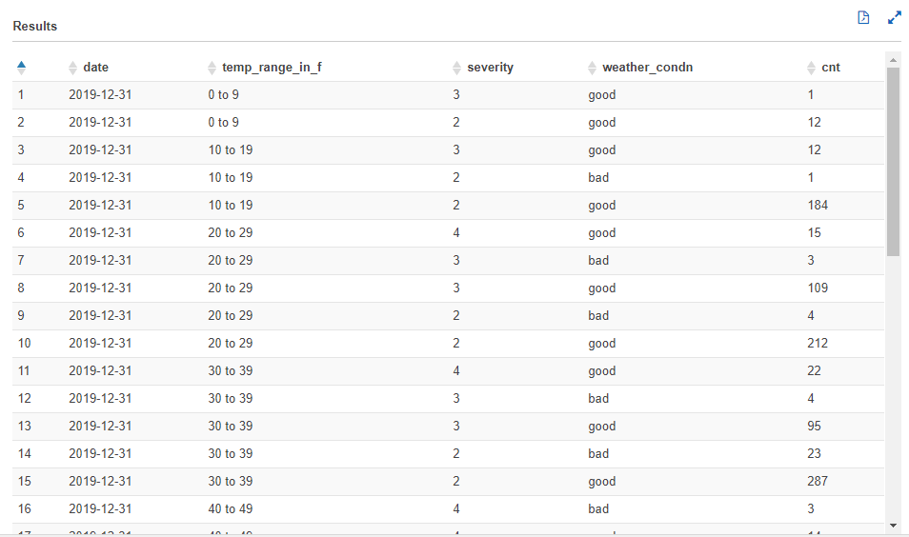

**wind_chill**

select date, wc_range_in_f, severity, weather_condn, count(*) as cnt

from

(select date(start_time) as date,

case

when wind_chill between -70 and -61 then '-70 to -61'

when wind_chill between -60 and -51 then '-60 to -51'

when wind_chill between -50 and -41 then '-50 to -41'

when wind_chill between -40 and -31 then '-40 to -31'

when wind_chill between -30 and -21 then '-30 to -21'

when wind_chill between -20 and -11 then '-20 to -11'

when wind_chill between -10 and -1 then '-10 to -01'

when wind_chill between 0 and 9 then '0 to 9'

when wind_chill between 10 and 19 then '10 to 19'

when wind_chill between 20 and 29 then '20 to 29'

when wind_chill between 30 and 39 then '30 to 39'

when wind_chill between 40 and 49 then '40 to 49'

when wind_chill between 50 and 59 then '50 to 59'

when wind_chill between 60 and 69 then '60 to 69'

when wind_chill between 70 and 79 then '70 to 79'

when wind_chill between 80 and 89 then '80 to 89'

when wind_chill between 90 and 99 then '90 to 99'

when wind_chill between 100 and 109 then '100 to 109'

when wind_chill between 110 and 119 then '110 to 119'

else 'wind_chill unknown'

end as wc_range_in_f,

case

when weather_condition = 'Clear' then 'good'

when weather_condition like 'Cloudy%' then 'good'

when weather_condition = 'Drizzle' then 'good'

when weather_condition = 'Drizzle / Windy' then 'good'

when weather_condition like 'Fair%' then 'good'

when weather_condition = 'Haze' then 'good'

when weather_condition like 'Light%' then 'good'

when weather_condition = 'Mist' then 'good'

when weather_condition like 'Mostly%' then 'good'

when weather_condition = 'N/A Precipitation' then 'good'

when weather_condition = 'Overcast' then 'good'

when weather_condition like 'Partial%' then 'good'

when weather_condition like 'Partly%' then 'good'

when weather_condition = 'Patches of Fog' then 'good'

when weather_condition = 'Scattered Clouds' then 'good'

when weather_condition = 'Shallow Fog' then 'good'

when weather_condition = 'Showers in the Vicinity' then 'good'

when weather_condition = 'Small Hail' then 'good'

when weather_condition = 'Thunder in the Vicinity' then 'good'

else 'bad'

end as weather_condn, severity

from us_accident_v3

where year(start_time) = 2019 and month(start_time) = 12 and day(start_time) = 31

order by month(start_time), date(start_time))

group by weather_condn, severity, wc_range_in_f, date

order by wc_range_in_f, severity desc, weather_condn, cnt desc;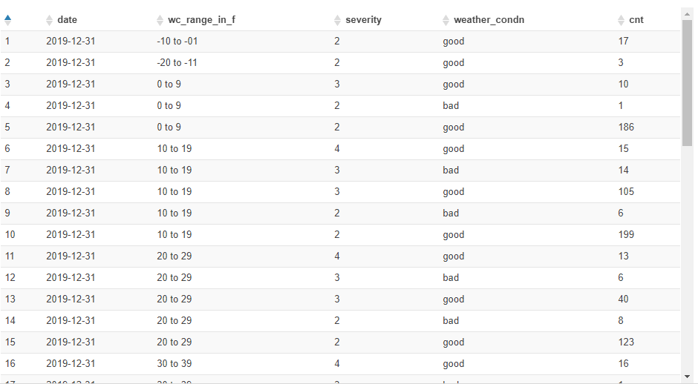

**humidity**

select date, hum_range, severity, weather_condn, count(*) as cnt

from

(select date(start_time) as date,

case

when humidity between 1 and 5 then '1 to 5'

when humidity between 6 and 10 then '6 to 10'

when humidity between 11 and 15 then '11 to 15'

when humidity between 16 and 20 then '16 to 20'

when humidity between 21 and 25 then '21 to 25'

when humidity between 26 and 30 then '26 to 30'

when humidity between 31 and 35 then '31 to 35'

when humidity between 36 and 40 then '36 to 40'

when humidity between 41 and 45 then '41 to 45'

when humidity between 46 and 50 then '46 to 50'

when humidity between 51 and 55 then '51 to 55'

when humidity between 56 and 60 then '56 to 60'

when humidity between 61 and 65 then '61 to 65'

when humidity between 66 and 70 then '66 to 70'

when humidity between 71 and 75 then '71 to 75'

when humidity between 76 and 80 then '76 to 80'

when humidity between 81 and 85 then '81 to 85'

when humidity between 86 and 90 then '86 to 90'

when humidity between 91 and 95 then '91 to 95'

when humidity between 96 and 100 then '96 to 100'

else 'humidity unknown' end as hum_range,

case

when weather_condition = 'Clear' then 'good'

when weather_condition like 'Cloudy%' then 'good'

when weather_condition = 'Drizzle' then 'good'

when weather_condition = 'Drizzle / Windy' then 'good'

when weather_condition like 'Fair%' then 'good'

when weather_condition = 'Haze' then 'good'

when weather_condition like 'Light%' then 'good'

when weather_condition = 'Mist' then 'good'

when weather_condition like 'Mostly%' then 'good'

when weather_condition = 'N/A Precipitation' then 'good'

when weather_condition = 'Overcast' then 'good'

when weather_condition like 'Partial%' then 'good'

when weather_condition like 'Partly%' then 'good'

when weather_condition = 'Patches of Fog' then 'good'

when weather_condition = 'Scattered Clouds' then 'good'

when weather_condition = 'Shallow Fog' then 'good'

when weather_condition = 'Showers in the Vicinity' then 'good'

when weather_condition = 'Small Hail' then 'good'

when weather_condition = 'Thunder in the Vicinity' then 'good'

else 'bad'

end as weather_condn, severity

from us_accident_v3

where year(start_time) = 2019 and month(start_time) = 12 and day(start_time) = 31

order by month(start_time), date(start_time))

group by weather_condn, severity, hum_range, date

order by hum_range, severity desc, weather_condn, cnt desc;

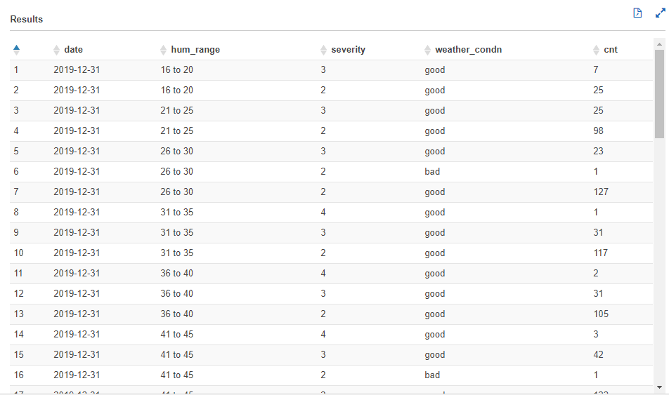

**pressure**

select date, press_range, severity, weather_condn, count(*) as cnt

from

(select date(start_time) as date,

case

when pressure between 0.00 and 3.50 then '0 to 3'

when pressure between 3.51 and 7.50 then '4 to 7'

when pressure between 7.51 and 11.50 then '8 to 11'

when pressure between 11.51 and 15.50 then '12 to 15'

when pressure between 15.51 and 19.50 then '16 to 19'

when pressure between 19.51 and 23.50 then '20 to 23'

when pressure between 23.51 and 27.50 then '24 to 27'

when pressure between 27.51 and 31.50 then '28 to 31'

when pressure between 31.51 and 35.50 then '32 to 35'

else 'pressure unknown'

end as press_range,

case

when weather_condition = 'Clear' then 'good'

when weather_condition like 'Cloudy%' then 'good'

when weather_condition = 'Drizzle' then 'good'

when weather_condition = 'Drizzle / Windy' then 'good'

when weather_condition like 'Fair%' then 'good'

when weather_condition = 'Haze' then 'good'

when weather_condition like 'Light%' then 'good'

when weather_condition = 'Mist' then 'good'

when weather_condition like 'Mostly%' then 'good'

when weather_condition = 'N/A Precipitation' then 'good'

when weather_condition = 'Overcast' then 'good'

when weather_condition like 'Partial%' then 'good'

when weather_condition like 'Partly%' then 'good'

when weather_condition = 'Patches of Fog' then 'good'

when weather_condition = 'Scattered Clouds' then 'good'

when weather_condition = 'Shallow Fog' then 'good'

when weather_condition = 'Showers in the Vicinity' then 'good'

when weather_condition = 'Small Hail' then 'good'

when weather_condition = 'Thunder in the Vicinity' then 'good'

else 'bad'

end as weather_condn, severity

from us_accident_v3

where year(start_time) = 2019 and month(start_time) = 12 and day(start_time) = 31

order by month(start_time), date(start_time))

group by weather_condn, severity, press_range, date

order by press_range, severity desc, weather_condn, cnt desc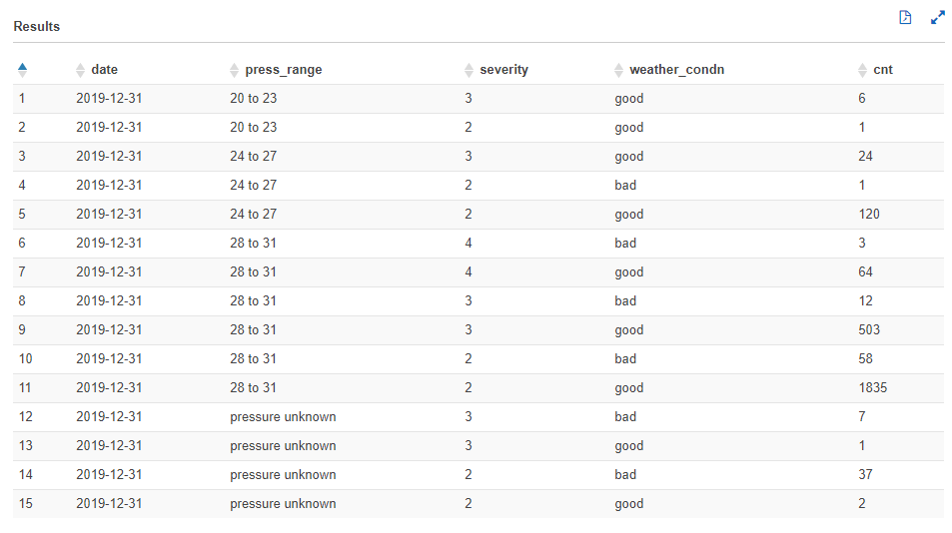

**visibility**

**wind-speed**

**precipitation**

**Bump**

**Crossing**

**Give_Way**

**Junction**

**No_Exit**

**Railway**

**Roundabout**

**Station**

**Stop**

**Traffic_Calming**

**Traffic_Signal**

**Turning_Loop**

## Query 6

select count(id) as NumAcc, severity, extract(week from start_time) as week, extract(year from start_time) as year

from timezone_table us_accident_v3

where (extract(year from start_time) > 2015 and extract(month from start_time)>1) or

(extract(year from start_time) > 2016)

group by severity, extract(week from start_time), extract(year from start_time)

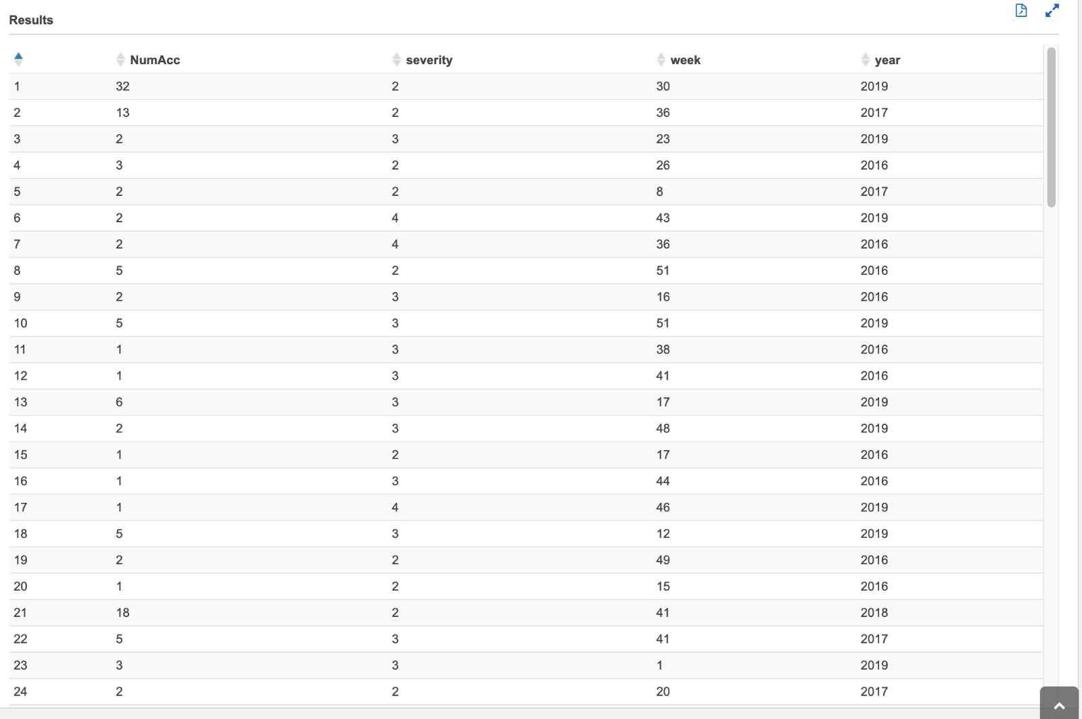

## Query 7

SELECT severity,

avg(distance) AS AvgDis,

stddev(distance) AS StdDevDis,

max(distance) AS MaxDis

FROM us_accident_v3

GROUP BY severity

ORDER BY severity

## Query 10

select Concept, sum(Frequency) as Freq from (with cte1 AS

(SELECT b.slno,

b.pattrn,

b.concpt,

cardinality(regexp_extract_all(lower(a.n_description),

lower(b.pattrn))) count

FROM us_accidents_dec_19_database.base_corpus3 a

CROSS JOIN us_accidents_dec_19_database.concept7 b

ORDER BY slno)

SELECT DISTINCT slno AS Serial_No,

concpt AS Concept,

pattrn AS Pattern,

sum(count)

OVER (partition by pattrn) AS Frequency

FROM cte1

ORDER BY slno) group by Concept

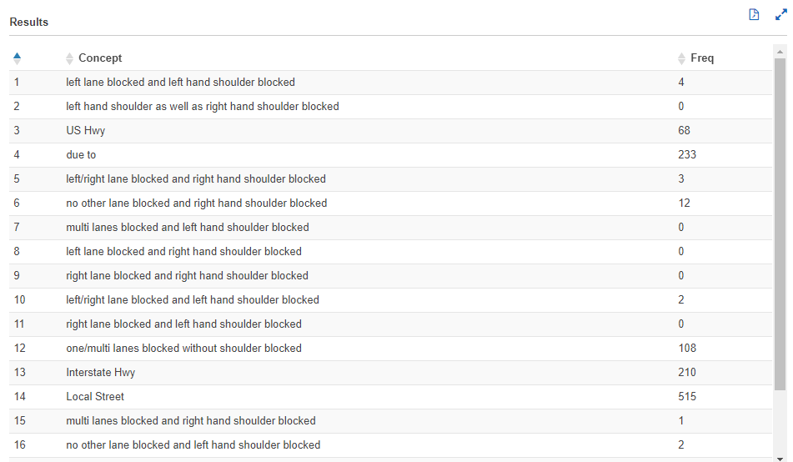

## Query 13

SELECT DISTINCT state,

date,

avg(sum_precip)

OVER (partition by date, state) AS avg_precip2

FROM

(SELECT DISTINCT state,

zipcode,

date,

sum(avg_precip)

OVER (partition by date, zipcode, state) AS sum_precip

FROM

(SELECT DISTINCT state,

zipcode,

date(start_time) AS date,

hour(start_time) AS hour,

minute(start_time) AS minute,

count(*) AS count,

avg(precipitation) AS avg_precip

FROM us_accidents_dec_19_database.us_accident_v3

GROUP BY state, zipcode, date(start_time), hour(start_time), minute(start_time)

ORDER BY count desc)

ORDER BY state, zipcode, date)

WHERE state = 'NY'

OR state = 'NJ'

OR state = 'PA'or state = 'IN'

OR state = 'WY'

ORDER BY state, date;

